Chat query | Respsonse
Technology Glossary query | The current glossary can be found at Materials and Processing Technology | NCEA (education.govt.nz) but doesn't yet have properties listed
Transform: | malleability, What about things like raising agents? Gluten? Binding and setting?
Properties: | flammable, soluble
I see innovation is not written in the standard any more, last year 92013 was only standard that had the word innovative. | Not explicitly in the standard, but is there in the unpacking:  https://ncea.education.govt.nz/technology/materials-and-processing-technology/1/2?view=unpacking  The intent of the Standard  This Achievement Standard assesses the ability of ākonga to experiment with different materials by exploring their properties in the development and creation of a purposeful outcome.  Ākonga are encouraged to be innovative in their experimentation with materials. This experimentation should be the inspiration for what they do with the materials.
Does the standard require the use of an unconventional material? | Experiment with different materials to develop a Materials and Processing Technology outcome  Experiment with different materials to develop a Materials and Processing Technology outcome | NCEA (education.govt.nz)  Ākonga will query processes as they explore materials’ properties. Starting questions could include:  - What can traditional or contemporary materials do?  - How can they be experimented with — what is the result?  - How can this knowledge be used in the development and creation of a purposeful outcome?  The term ‘unconventional’ has not been used. ‘Different’ can be interpreted in many ways. What is accessible in your school context?
Will there be any external moderation of the results from this standard? Assuming that would be if high value, but also a huge cost to have it done. | Do you mean NZQA moderation? This will happen as part of the usual moderation process.
Exploring materials without giving them an end purpose at the start could be very wasteful. I don't have an unlimited budget or unlimited time. | https://ncea.education.govt.nz/technology/materials-and-processing-technology/1/2?view=standard  Purpose Students are able to experiment with different materials to develop a Materials and Processing Technology outcome.
Transforming | steaming wood,
steaming wood, would steaming be manipulating? | Is the structure/composition of the material staying the same? – if so – it could fall under manipulation as well.
Is cooking a product, ie a cake batter into a cupcake, considered transforming? This would alter structure of eggs, flour etc | Transforming: Working with existing materials in ways that change their structure to maximise product performance
Combining | Resin and wood, rebar in concrete for strength, embroidery?
So combining not gluing? | Gluing is a joining technique.
Manipulating | Manipulating in food can also be scooping batter, filling a cake tin, cutting, separating egg yolk and white...
I wonder if the introduction of different flours could work GF flour, Rice, Potato, Coconut flour | That would be combining.  Applying heat would change structure of materials, and therefore transforming the material - ie eggs would go from a liquid to solid
Great book flashed up on screen | Technology Education in New Zealand, A guide for teachers Routledge ISBN 978-0367-41897-7
for this standard can you achieve with only one technique? | In Materials and Processing Technology, experimentation refers to trying out ideas or methods for the purpose of discovery.  Identify how the exploration/experiments informed their understanding of the properties of materials. For example, what was discovered about material properties as a result of:  ○ transforming, and/or  ○ combining, and/or  ○ manipulating, and/or  ○ forming, and/or  ○ a combination of all four techniques and processes.  A student could produce an outcome that focuses on one of the above, however through their learning they will most likely have learned about and experienced most of them.
How will students know if it will maximise product performance if they are not supposed to know what the product is at the start? | "A purposeful context may arise as a result of the process of materials experimentation and/or it may be identified as part of a given brief."  Brief development or given brief will guide what product they intend to make, therefore they should be able to experiment to maximise that product performance.
Is adding hand embroidery to a fabric, manipulating a fabric? | It could be considered manipulating with sufficient justification – inclined to think it is linked more to combining.
The potato example is of transformation not manipulation? | I think this is a good example where it could be considered either dependent on the approach and justification.
Layering up fabric, wadding, fabric and then stitching over the whole to make a quilted fabric, is that manipulating or forming? | Quilting forms a new fabric that has a different physical structure to the separated contributing layers. However, by quilting the materials are being manipulated to maximise each layers contribution to the performance of a quilt and what the intention of quilting fabric is.
I was mistaken last week when we briefly discussed this...I thought it was mentioned that a feasible outcome was required not necessarily a physical outcome...? | Both the internals need physical outcomes.  The External  Achievement Standard 1.4 (92015): Demonstrate understanding of techniques selected for a feasible Materials and Processing
Is group work appropriate? We are making small savoury pies for a big morning tea (100 people). Can akonga develop the recipe together? Can they make the outcome together...difficult to make small quantities en mass. | Group work to learn about the properties of materials is great. However, students need to evidence what they have learned and its application, individually.
Can a person do 20 A4 pages | ttps://ncea.education.govt.nz/technology/materials-and-processing-technology/1/2?view=conditions  For 1.2 Experiment with different materials to develop a Materials and Processing Technology outcome | NCEA (education.govt.nz)  Examples of student submissions could include one of the following methods of presentation:  - a digital slide presentation (no more than 20 slides at size 12 font or bigger)  - a collection of scanned paper evidence (no more than 10 A3 sides of paper)  - a video or recorded oral presentation (3-4 minutes long)  - a combination of the above, totalling no more than the equivalent of 750-800 words.  Students should not be limited to these and decisions about format should be made in negotiation with the assessor.
Will we be doing webinars like this for 92014 and 92105 ? | Great question – I’ll see what I can do
Do you think it would be possible to create some exemplars that only use 750-800 words? | ZQA is responsible for exemplars - due to a small number of pilot schools there may not have been suitable exemplars available. Hopefully as more work is submitted more examplars are made available.
Can they be given a template to use as a guide? Like a slides with headings to prompt them. | Templates can be useful, however take care not to over template. A question for an NZQA workshop – what is over templating and what does it look like?
can the student use lots of annotated photos of project as evidence as opposed to lots of writing. | The learning should be evidenced in the best way for that student – see examples above.
Are there any examples for electronics/robotics? or do I need to use Digital Technologies? | MPT has been developed to be accessible to electronics and robotics. Exemplars will be developed by NZQA as work from these contexts submitted for external moderation.
When is the final date for internal submissions? | Materials and Processing Technology (Level 1 only) :: NZQA
Screencastify link | https://www.screencastify.com/
What is the equivalent for Microsoft? | You can insert media and just insert some audio...  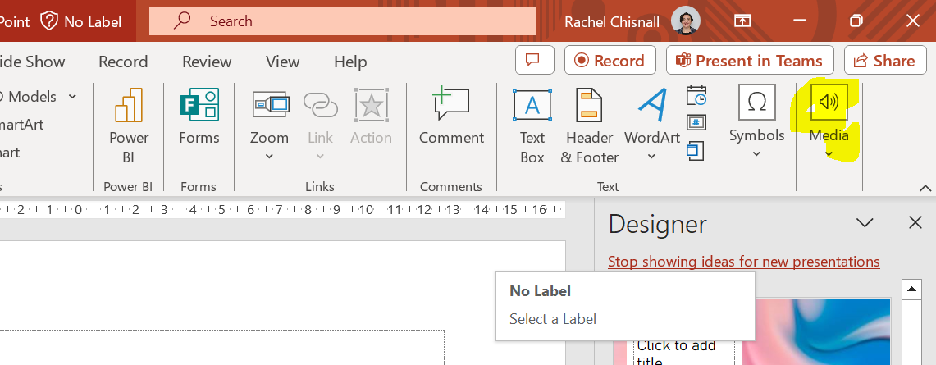  OR dig a little deeper and find the recording tab (it might not be turned out automatically) and then you can record the whole slide show. 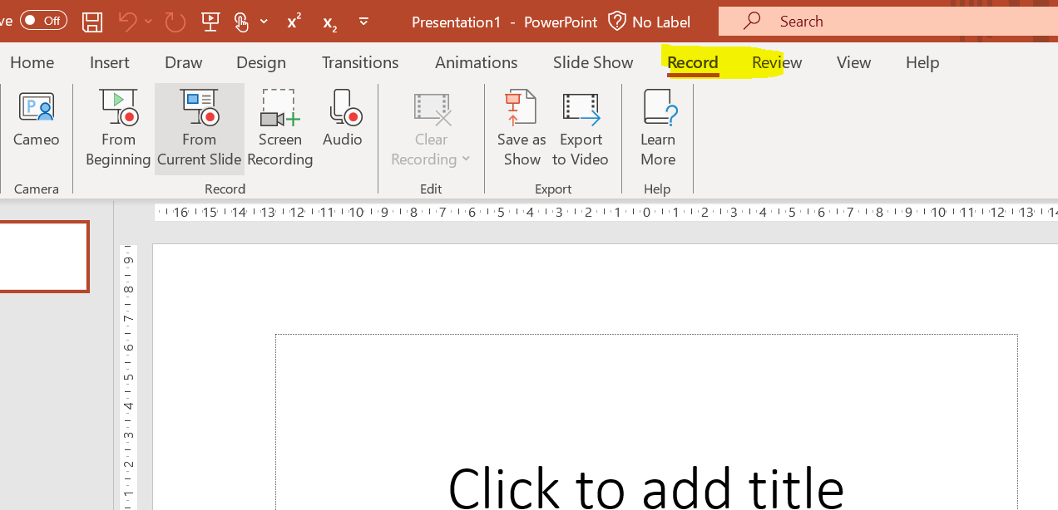
Can you please let us know how to send this as moderation? Is there a file size limit for sending this? | Talk to your Principals nominee - or the information can be found at Principal's Nominee handbook - 2024 (nzqa.govt.nz)
I would like a guide on how to teach students how to gather stakeholder feedback. | - Student reflection.  - Ask appropriate (the right person for that point in development – this will continually change. They will consult with the end user the most during development) stakeholders for feedback – teach students how to ask questions to get useful answers.  - What have I learned from the feedback?  - How will this inform my practice?

